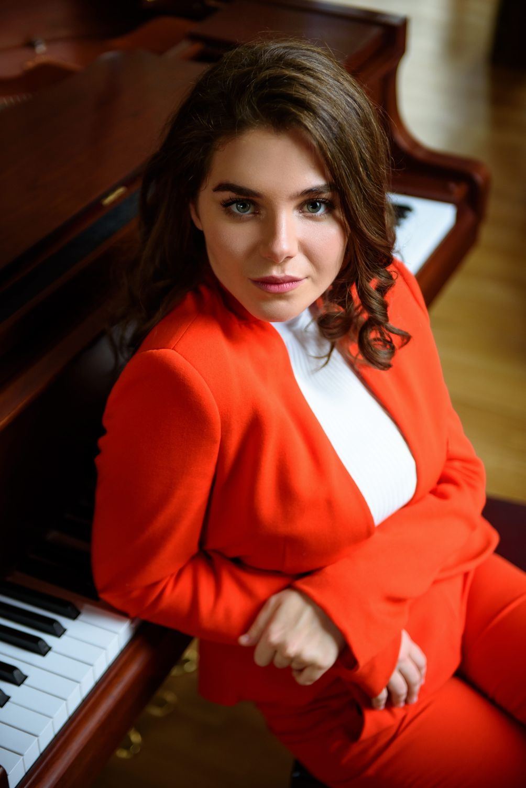

Sherling Mariamna (07/04/2001)

Solo repertoire:

- Wolfgang Amadeus Mozart "Sonata No. 12 in F ¬ major, К.332, movement III" (07:00)
- Wolfgang Amadeus Mozart "Sonata in C major, К.576" (14:10)
- Carl Maria von Weber "Perpetual Motion" (04:04)
- Mikhail Ivanovich Glinka "Nocturne" Parting "(03:45)
- Johann Sebastian Bach "English Suite" in A minor No. 5
- Johann Sebastian Bach "The Well-Tempered Clavier" Volume I "Prelude and Fugue" in E minor
- Johann Sebastian Bach - Score in B Flat Major No. 1
- Ludwig van Beethoven's Piano Sonata No. 3 C-Major "part 1 (10:27)
- Ludwig Van Beethoven "32 Variations in C-Minor" (11:20)
- Ludwig van Beethoven, Sonata no. 26 Es-dur (34 min) (34 min)
- Ferenc "Consolation" List No. 2, 5
- Franz Liszt "Study after the Caprices of Paganini" Es-dur
- Franz Liszt "Study after Caprices by Paganini No. 3 in G sharp minor" Campanella "(05:14)
- Franz Liszt "Venice and Naples" (09:00)
- Franz Liszt "Hungarian Rhapsody No. 12"
- Frederic Chopin "Impromptu No. 1 in A flat major, opus 29" (04:15)
- Frederic Chopin "Impromptu Fantasy"
- Frederic Chopin "Nocturne No. 2, opus 9" (04:00)
- Frederic Chopin "Scherzo No. 2, opus 31" (09:30)
- Frederic Chopin "Etudes No. 2, 4, 7, 12, 21"
- Frederic Chopin, scherzo number 1 h-moll (10 min), scherzo number 3 c-moll (12 min)
- F. Chopin Scherzo No. 3 cis-moll op.39 (7:00)
- F. Chopin Scherzo No. 4 E-dur op.54 (11:00)
- 24 F. Chopin mazurkas op.17
- Jean-Philippe Rameau "Chicken" (06:20)
- George Gershwin "Prelude No. 1 in B-flat major" (01:40)
- Pavel Yulievich Schletser "Concert Etude in A-flat major, opus 1, No. 2" (02:56)
- Felix Mendelssohn “Midsummer Night's Dream Concert Overture” (12:01)
- Felix Mendelssohn "Rondo Capriccioso" Op.14 (06:40)
- Maurice Ravel "Alborad's Prelude (from the cycle" Reflection ") (06:38)
- Maurice Ravel "Sad Birds" from the cycle "Reflection"
- Sergei Prokofiev "Sonata No. 3" (07:12)
- Sergei Rachmaninov "Prelude op.23 No. 5" (04:00)
- Alexander Scriabin “Study No. 9 op.8 gis-¬moll "
- Alexander Scriabin sonata No. 9, op.62
- Alexander Scriabin etude No. 5, Op. 42 cis-moll.
- Alexander Scriabin preludes op.15
- Dmitry Shostakovich "Prelude and Fugue gis-¬moll"
- Joseph Haydn "Sonata C-¬dur No.23"
- Joseph Haydn Sonata in e-moll op.53
- Igor Stravinsky suite from the ballet "The Firebird"

Repertoire with orchestra:
- Dmitry Kabalevsky "Piano Concerto No. 3 in D major" part 3 (05:40)
- Joseph Haydn "Concerto in D major for piano and orchestra" part I
- Edvard Grieg “Concerto for piano and orchestra in A minor” op.16, movement I (12:50)
- Frederic Chopin "Concerto for Piano and Orchestra No. 2 in F minor" (40:00)
- Wolfgang Amadeus Mozart "Concert 23"
- Wolfgang Amadeus Mozart "Concert 25"
- Mozart - Concerto No. 15 in B-flat Major - KV-450.
- 8.C. Saint-Saens Concerto for piano and orchestra in g-moll op.22 (24:39)
- Alexander Scriabin concert for piano and orchestra fis-moll op.20.
- Sergei Prokofiev Concerto for Piano and Orchestra No. 3 C-dur op.26.
- Sergei Prokofiev - Concerto No. 3 for piano and orchestra - C Major.

