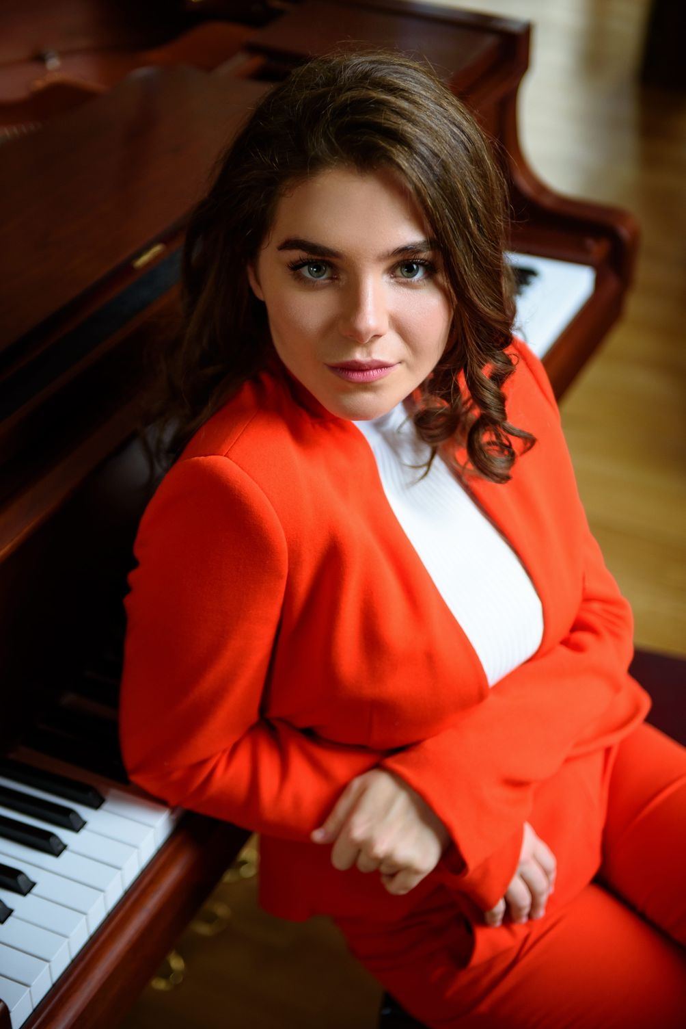

Mariamna Sherling
F-NO

Mariamne Sherling was born on April 7, 2001 into a family of professional musicians and from an early age was brought up in the best traditions of classical music.
In 2009, Mariamna was admitted to the Moscow Gnessin Secondary Special Music School, piano class (Class of M.Sh. Shalitaeva).
And in less than a year she became the winner of the Chopin and Schumann competitions, at the same time participating in various national festivals and competitions, where she was awarded diplomas and the title of laureate. Begins performing with the "Gnessin virtuosi" chamber orchestra under the direction of Mikhail Khokhlov.
For eight years Mariamna has received more than nine diplomas for participation in various festivals, including diplomas of the 1st and 2nd Family Ensembles Festivals in 2006 and 2007.
In December 2009 she took part in the Tchaikovsky festival in Moscow.
Three years later, Mariamna was awarded a diploma for participating in the Moscow Beethoven festival, later that same year she became a laureate of Young to Young, the innovative Open Stage project of the Vladimir Spivakov International Charitable Foundation.
In November 2012, Mariamna performed at the XIII International Television Competition for Young Musicians "The Nutcracker" in Moscow, receiving the title of laureate.
In October 2013, Mariamna took part in the VIII International Yuri Bashmet Festival (Minsk, Belarus) and less than a year later she received the 1st prize and became the laureate of the 11th International Rotary Competition.
Mariamne took part in the XV International Chamber Music and Young Talent Course Musica Mundi in Brussels, Belgium in July 2013.
A great triumph in Mariamna's musical career is receiving the 1st prize and a laureate diploma at the 10th International Competition "Young Virtuosos", which took place in Sofia, Bulgaria, in March 2014.
In 2015, Mariamna received 1st Prize and Laureate Diploma in the II George Gershwin International Competition in New York, USA.
In 2016-2020 - Concerts at the Moscow State Philharmonic, the Moscow State Conservatory, the St. Petersburg Philharmonic, Voronezh, Kostroma, Switzerland, Israel.
In 2018, she was awarded the Moscow Mayor's Prize.
Concerts with symphony orchestras and solo performances in various cities of Russia (Kostroma, Kaluga, Voronezh, Moscow, St. Petersburg) and abroad (Switzerland, Italy, Germany, USA and others).
Conductors - Ilya Norshtein, Pavel Gershtein, Yuri Bashmet, Vladimir Spivakov, Sergey Stadler, Denis Vlasenko.
In 2019, she is a laureate of the Youth Delphic Games in Rostov-on-Don.
Since 2019 she has been a student of the Moscow State Conservatory. P.I. Tchaikovsky (class of Professor N.V. Trull).
In 2020, the laureate of the International Competition. Alexander Scriabin in Grosseto, Italy.

